**Types of Performance Testing Process:**

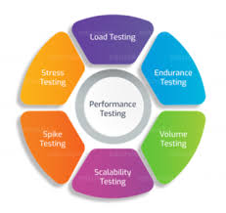

**The following seven steps describe what’s involved in the performance testing process:**

**Step 1: Identify the Testing Environment**

The testing environment or the test best is where all the magic happens. Identify the testing environment and know [what testing tools are available](https://www.simplilearn.com/best-automation-testing-tools-for-software-development-article) at your disposal. Understand the details of all the hardware, software and different network configurations ahead of time.

**Step 2: Identify the Performance Metrics**

In addition to the general performance metrics such as response time, throughput and constraints, it is also important to identify the performance success criteria. Oftentimes, there may not be a wide enough variety of performance benchmarks that you can identify. You can find similar applications which are already successful in order to set performance goals.

**Step 3: Plan and Design Performance Tests**

Identify a number of key scenarios by taking into account user variability, test data, and plan performance. This is required to simulate a variety of use cases and outline what metrics will be gathered.

**Step 4: Configure the Test Environment**

Arrange all the necessary testing tools and monitoring resources to prepare the testing environment before execution.

**Step 5: Implement the Test Design**

Design all the performance tests according to your performance criteria and metrics.

**Step 6: Run the Tests**

Execute and run the performance tests. Also, capture and monitor all the test data that is generated.

**Step 7: Analyze, Tune and Retest**

After every performance test, analyze the finding and fine tune the test again to see an increase or decrease in performance. Run the tests again using the same or different parameters.